



eProject Document
Nexus Service Marketing
System
Group 5
Members | Chu Van An - Student600865(Team Leader)  Tran Quoc Long - Student603831  Le Thanh Hop – Student597454  Nguyen Ba Son – Student597200
Instructor | Lai Duc Chung
Batch | C1207I
Semester | III

 Date of issue 09-13-2013 

Hardware and Software Requirements

Minimum Hardware Requirements
- CPU: Pentium IV 2.00 GHz.
- RAM: 512 MB.
- Hard Disk: 5 GB.
- OS: Window 2000/XP/Server 2003.
- Internet Explorer 7.0 or FireFox 12.0
- Internet information services (IIS) 5.1 or higher.

Recommended Hardware Requirements
- CPU: Dou Core 2.00 GHz or higher.
- RAM: 2 Gb or higher.
- Hard Disk: 80 GB or higher.
- OS: Window 7.

Software Requirements
- Environment: Microsoft .NET Framework 2.0 or later
- Database Management System: Microsoft SQL Server 2005 or later
- IDE: Microsoft Visual Studio 2008 or later
- Web Server: Internet Information Services (IIS 7.0) or later
- FireFox 12.0.
Summary :
+ Extracting files “Nexus_Group5”.
+ Copy extracted files and folder such as Database, Source Code to the drive that is enough space for them. For example Drive D or E.
However, you should copy “NexusService” folder to the “C:\Inetpub\wwwroot\” folder on the local drive.
+ Computer should have internet to execute send e-mail to member or customer.

Install Application “Nexus Service”.

Attach Database Of Application
- Step 1 : Start → All Programs → Microsoft SQL Server 2005 → SQL Server Management Studio.
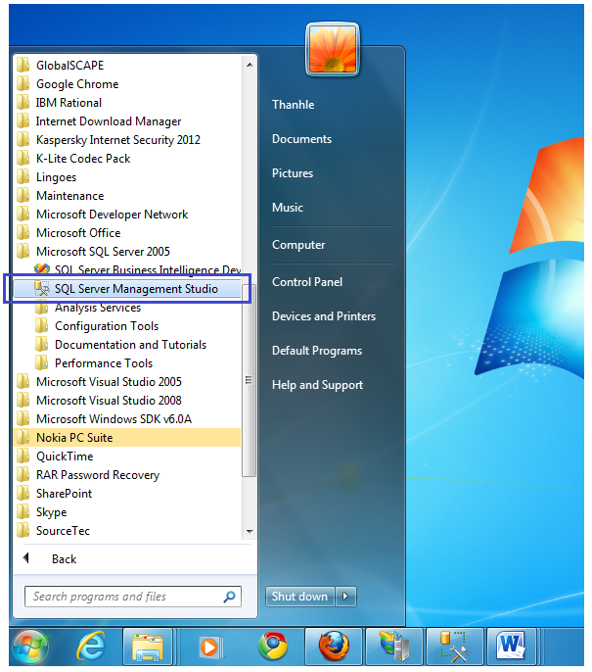

- Step 2 : Login in SQL Server 2008 :
- Enter information necessary :
  - Authentication : SQL Server Authentication.
  - Login and password of your computer.
- Click button “Connect”.

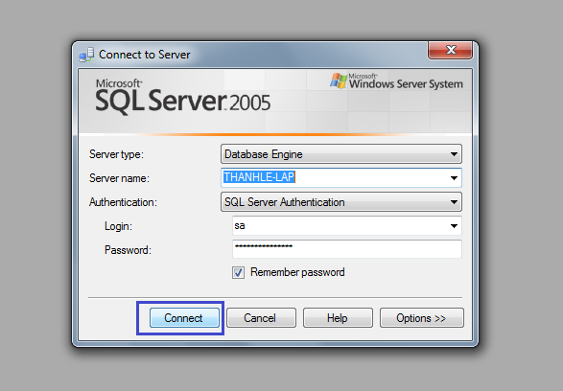

- Step 3 : Attach database of application .
- Right Click on “Database”, then choice “Attach…”. The form “Attach Database” will appear:

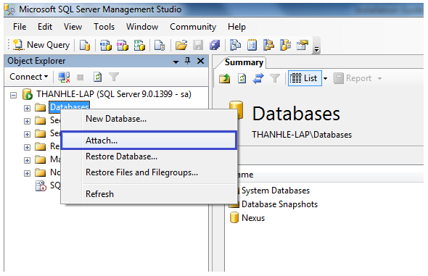

- Step 4 : Attach database of application .
- The form “Attach Database” appear :
  - Click button “Add”, and then search folder “Database” to file “Nexus.mdf”
  - After click button “Ok”.

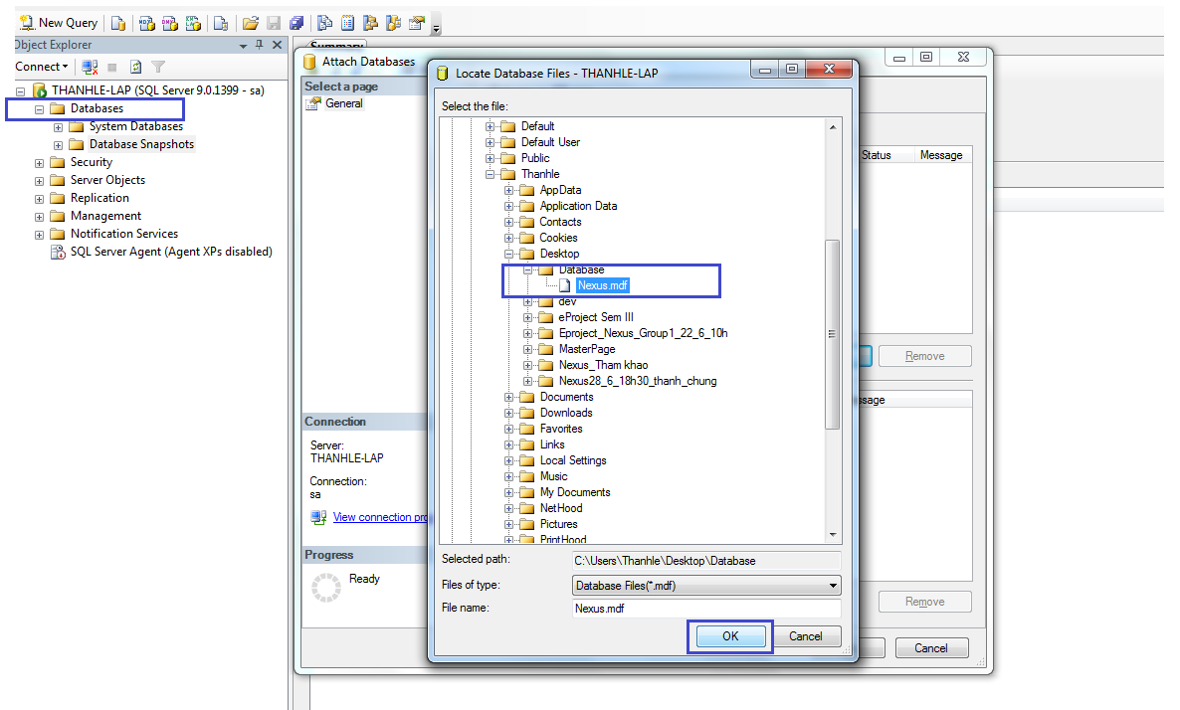

- Step 5 : Click button “OK” :
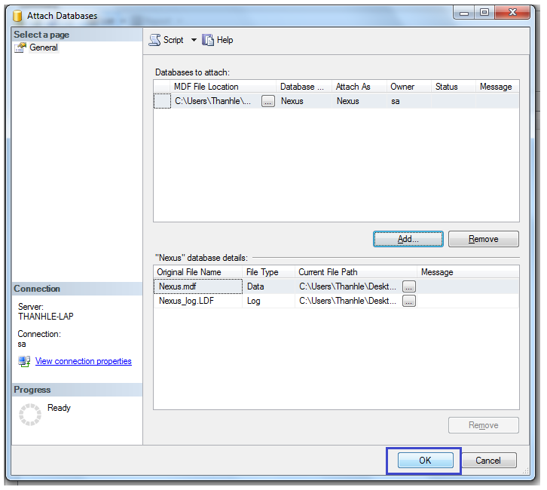
- Step 6 : Attach successfully when there are :
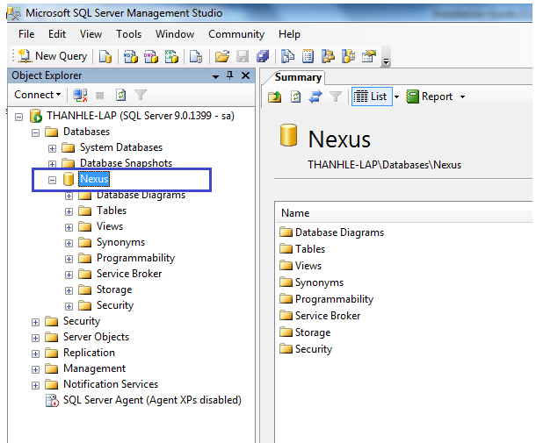

Configuration Web.Config file
Open folder which was installed in hard disk as this path :
- C:\inetpub\wwwroot\NexusService\Web.Config or path you save project.
Right Click ‘Web.Config’ choice open by Notepad
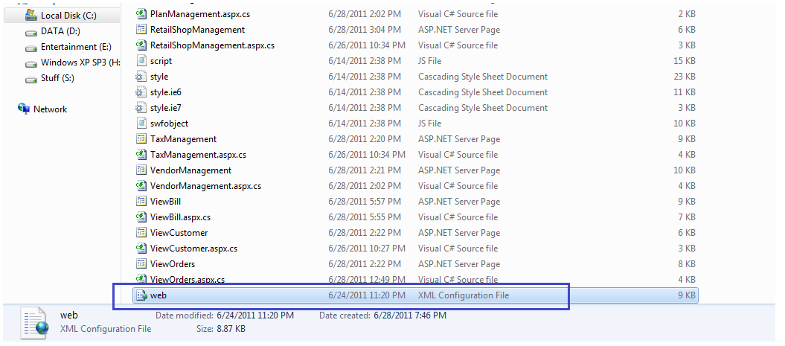
Open This file Web.Config by NotePad program.
Then you fix the connection string according to Data Source name,UserID and Password of your Computer and SQLServer
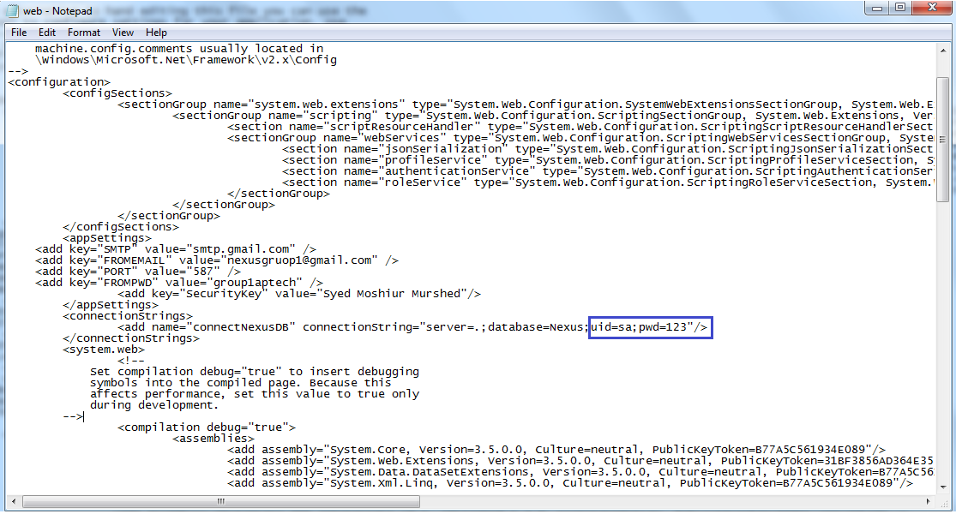
<connectionStrings>
<add name="connectNexusDB" connectionString="Server=.;database = Nexus; uid=sa;pwd=123"/>
</connectionStrings>
- Start browse web
- The Main Page: http://localhost/NexusService/MainPage.aspx
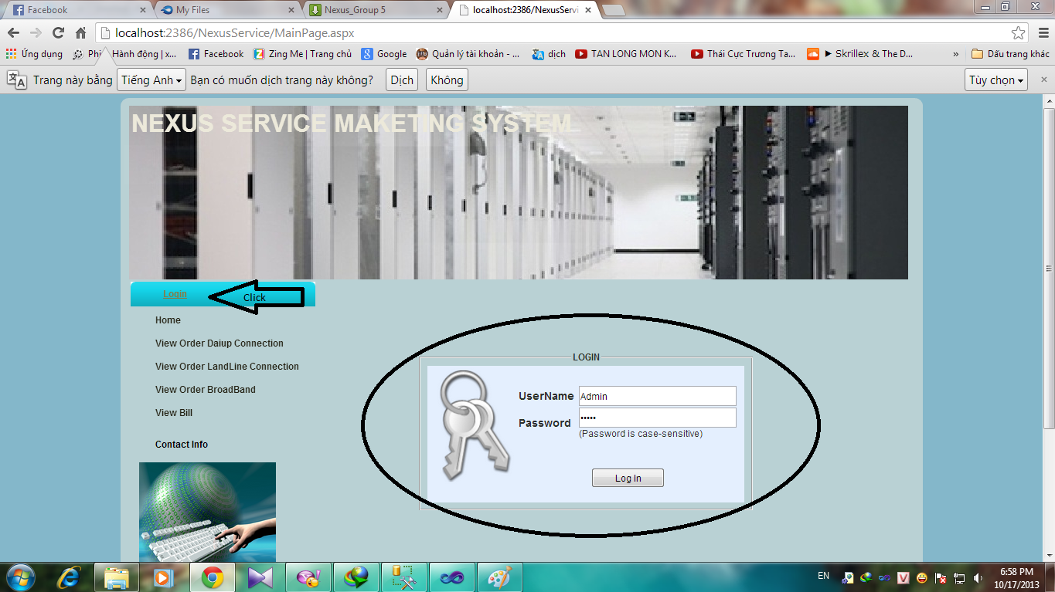
- Role to login system :
- Admin :
- Username : Admin
- Password : admin
- Accountant:
- UserName: long
- Password: admin
- Technician:
- UserName: chuvanan
- Password: admin
Note:
- When a UserName was created default password is same with UserName, both UserName and Password was sent to email of user.
- Password is case-sensitive

- If You logined with Admin Role, the page home of admin will be appear with vertical menu of Admin

THE END

